Project - High Level Design
on
Autonomous Retail Researcher Agent
  - Course Name: Agentic AI
Institution Name: Medicaps University – Datagami Skill Based Course

Student Name(s) & Enrolment Number(s):
Sr no | Student Name | Enrolment Number
1. | Arsh Patidar | EN22CS301204
2. | Aniket Kushwah | EN22CS301124
3. | Anuj Singh Rathore | EN22CS301166
4. | Anurag Didolkar | EN22CS301169
5. | Avani Gupta | EN22CS301236
6. | Amit Patidar | EN22CS301114

Group Name: Group 09D2
Project Number: AAI-21
Industry Mentor Name:
University Mentor Name:
Academic Year:2026

Table of Contents
Sr No. | Contacts | Page No.
1. | Introduction | 3-4
 | 1.1 Scope of the document
 | 1.2 Intended Audience
 | 1.3 System Overview
2. | System Design | 4-12
 | 2.1 Application Design
 | 2.2 Process Flow
 | 2.3 Information Flow
 | 2.4 Components Design
 | 2.5 Key Design Considerations
 | 2.6 API Catalogue
3. | Data Design | 13
 | 3.1 Data Model
 | 3.2 Data Access Mechanism
 | 3.3 Data Retention Policies
 | 3.4 Data Migration
4. | Interfaces | 14
5. | State and Session Management | 14
6. | Caching | 14
7. | Non-Functional Requirements | 15
 | 7.1 Security Aspects
 | 7.2 Performance Aspects
8. | References | 15

High Level Design (HLD)
1. Introduction
The purpose of this document is to provide a high-level design of the Autonomous Retail Researcher Agent. It explains the system architecture, components, data flow, and design considerations involved in building the system.

1.1 Scope of the Document
This document presents the High-Level Design (HLD) of the Autonomous Retail Researcher Agent, an AI-driven system designed to automate retail data analysis and research. The scope of this document includes the architectural overview, system modules, process workflows, data design, and interaction between different layers of the system.
It provides a clear understanding of how the system processes user queries, retrieves information from external sources, and generates meaningful insights using advanced AI techniques. This document does not cover low-level implementation details such as code structure or deployment configurations but focuses on the logical and structural design of the system.
The document also outlines system boundaries, assumptions, dependencies, and constraints to help stakeholders understand the system's capabilities and limitations.

1.2 Intended Audience
This document is intended for a wide range of stakeholders involved in the project lifecycle:
- Developers: To understand system structure and component interactions
- Project Evaluators and Faculty: To assess design quality and technical depth
- Industry Mentors: To evaluate practical applicability and scalability
- Students/Researchers: To understand agent-based AI system design

It serves as a reference guide for implementation, evaluation, and future enhancements of the system.

1.3 System Overview
The Autonomous Retail Researcher Agent is a smart AI-powered system designed to automate the process of retail research and analysis. Traditionally, retail research involves manual data collection, analysis, and report generation, which is time-consuming and inefficient. This system eliminates manual effort by leveraging Agentic AI, Large Language Models (LLMs), and tool integration frameworks.
The system accepts user queries such as market trends, product comparisons, or pricing insights. It uses a multi-agent architecture where each agent performs a specific task. The Planner Agent decomposes the query into manageable tasks, the Research Agent gathers relevant data from multiple online sources, and the Summarizer Agent processes and converts the collected data into structured insights.
The system integrates external tools such as web search engines and web scrapers to fetch real-time data. The collected data is then processed using LLM APIs to ensure accurate and meaningful results. Finally, the system stores the output in a knowledge repository, enabling future reuse and faster responses.

2. System Design
2.1 Application Design
The application follows a layered and modular architecture, ensuring flexibility, scalability, and maintainability.
- Presentation Layer (Frontend):
Provides a user-friendly interface for entering queries and displaying results. It ensures ease of interaction and accessibility.
- Application Layer (Backend):
Handles core logic, including agent coordination, API communication, and workflow execution. Implemented using Python for flexibility and integration capabilities.
- AI Processing Layer:
Utilizes LangChain and CrewAI to manage multi-agent workflows and integrate LLM capabilities for intelligent processing.
- Integration Layer:
Connects with external services such as search APIs and LLM APIs to fetch and process real-time data.

- Data Layer:
Responsible for storing processed outputs and maintaining a knowledge base.
This design ensures loose coupling between components, making the system easier to scale and maintain.

2.2 Process Flow
The system follows a structured and sequential workflow to ensure efficient processing:
- The user submits a query through the interface.
- The Planner Agent analyzes the query using LLM capabilities and divides it into smaller subtasks.
- The Research Agent executes these tasks by interacting with external tools such as web search APIs.
- The Web Scraper extracts relevant information from the retrieved sources.
- The Parser cleans and structures the raw data to make it suitable for processing.
- The LLM processes the structured data to identify patterns, trends, and insights.
- The Summarizer Agent compiles the processed information into a concise and structured report.
- The final output is stored in the database and presented to the user.
This pipeline ensures accuracy, efficiency, and scalability in handling complex queries.

2.3 Information Flow
The system ensures smooth and logical data movement across different components:
- Input Flow:
User query is captured and passed to the agent system.
- Processing Flow:
The query flows through multiple agents and tools, where it is transformed from raw input into structured information.
- Output Flow:
The processed summary is stored and displayed to the user.

Additionally, feedback loops can be incorporated to refine results based on stored knowledge, improving system performance over time.

2.4 Components Design
User Interface
The UI acts as the entry point of the system. It captures user queries and displays results in a structured and readable format. It may include features such as query history and result filtering.
Agent Layer
The core intelligence of the system lies in the agent layer:
- Planner Agent: Responsible for understanding the query and breaking it into logical subtasks.
- Research Agent: Executes tasks by collecting data from multiple sources.
- Summarizer Agent: Processes and converts collected data into meaningful insights.
This multi-agent approach ensures task specialization and efficient execution.
LLM Layer
The LLM layer provides cognitive capabilities to the system. It is responsible for natural language understanding, reasoning, and summarization. It ensures that outputs are context-aware and relevant.
Tool Layer
The tool layer integrates external functionalities:
- Web search for retrieving data
- Web scraping for extracting content
- Parsing for data cleaning
These tools enable the system to gather and process real-time information.
Storage Layer
This layer stores processed outputs and maintains a knowledge repository. It allows the system to reuse previously generated insights, improving efficiency and reducing redundant processing.

2.5 Key Design Considerations
- Scalability: The system should handle increasing user queries without performance degradation.
- Modularity: Components should be independent for easy updates and maintenance.
- Accuracy: Ensure high-quality data processing and reliable outputs.
- Performance: Optimize API calls and reduce response time.
- Fault Tolerance: Implement retry mechanisms and error handling for failures.
- Extensibility: Design should allow future integration of ML models and advanced analytics.

2.6 API Catalogue
- LLM API:
Used for processing natural language queries, reasoning, and generating summaries.
- Search API:
Retrieves relevant web pages based on user queries.
- Scraper API:
Extracts textual content from web pages.
- Parser Module:
Cleans and structures extracted data.
All APIs are securely integrated and managed through the backend.

UML Diagrams :-

Sequence Diagram

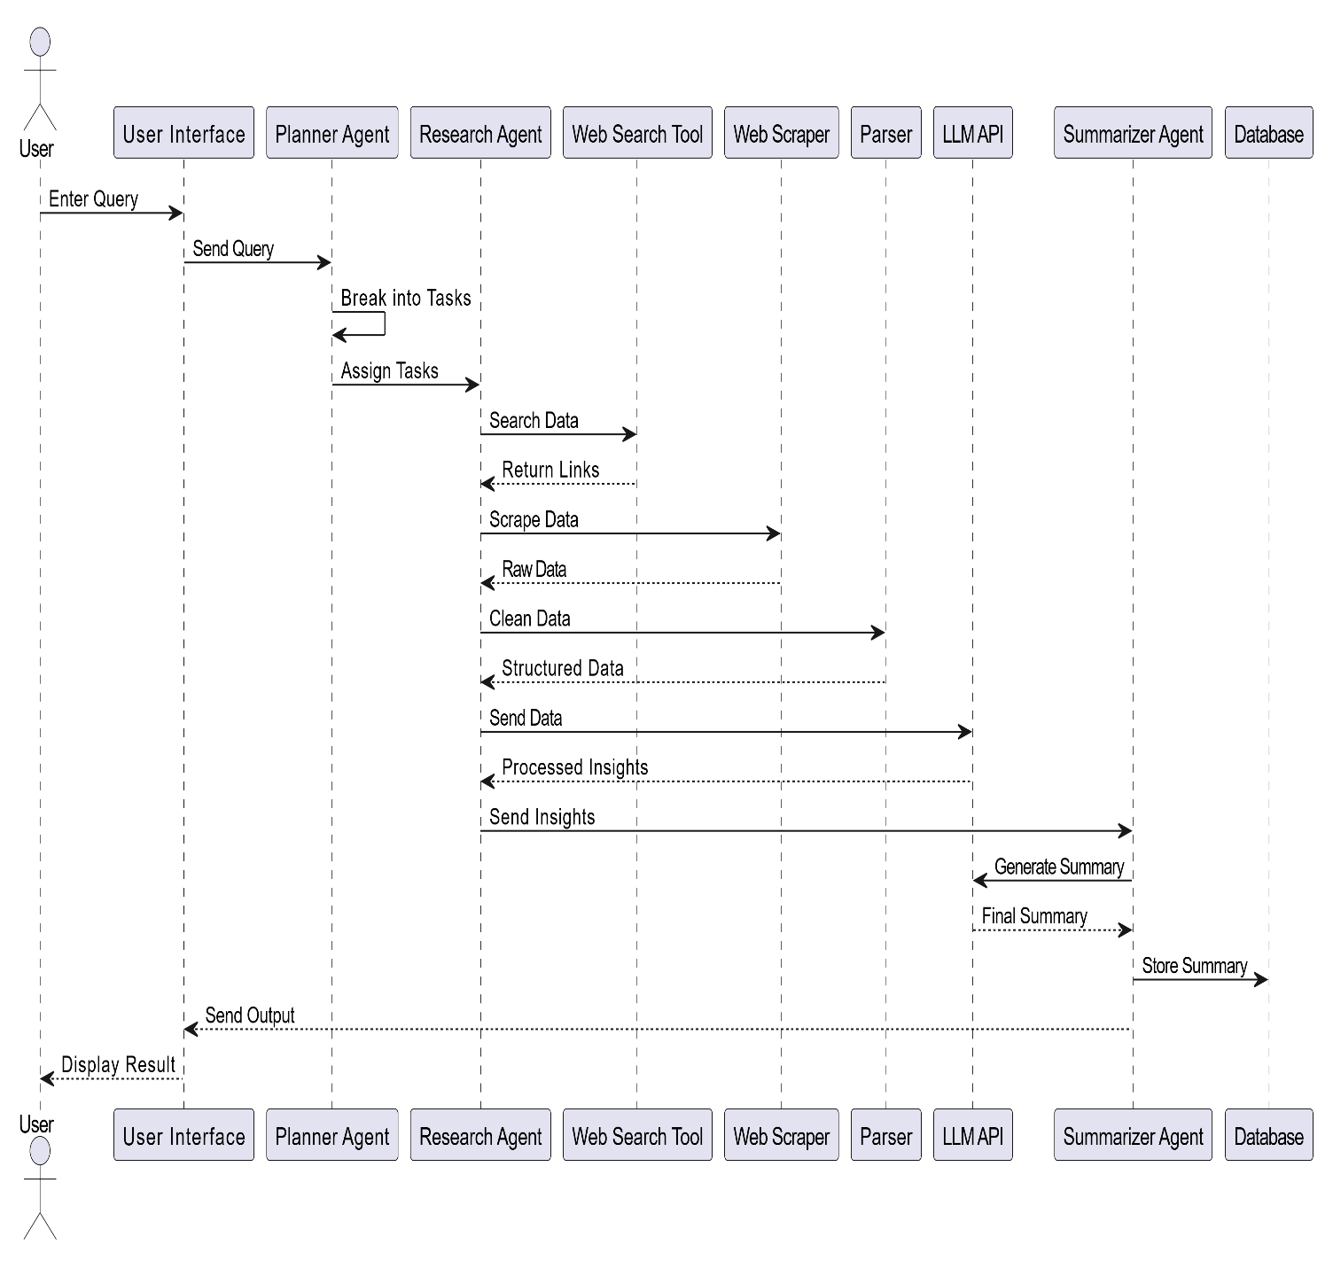

Activity Diagram

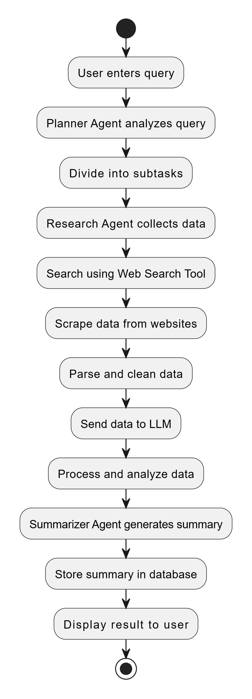

Entity Relationship Diagram

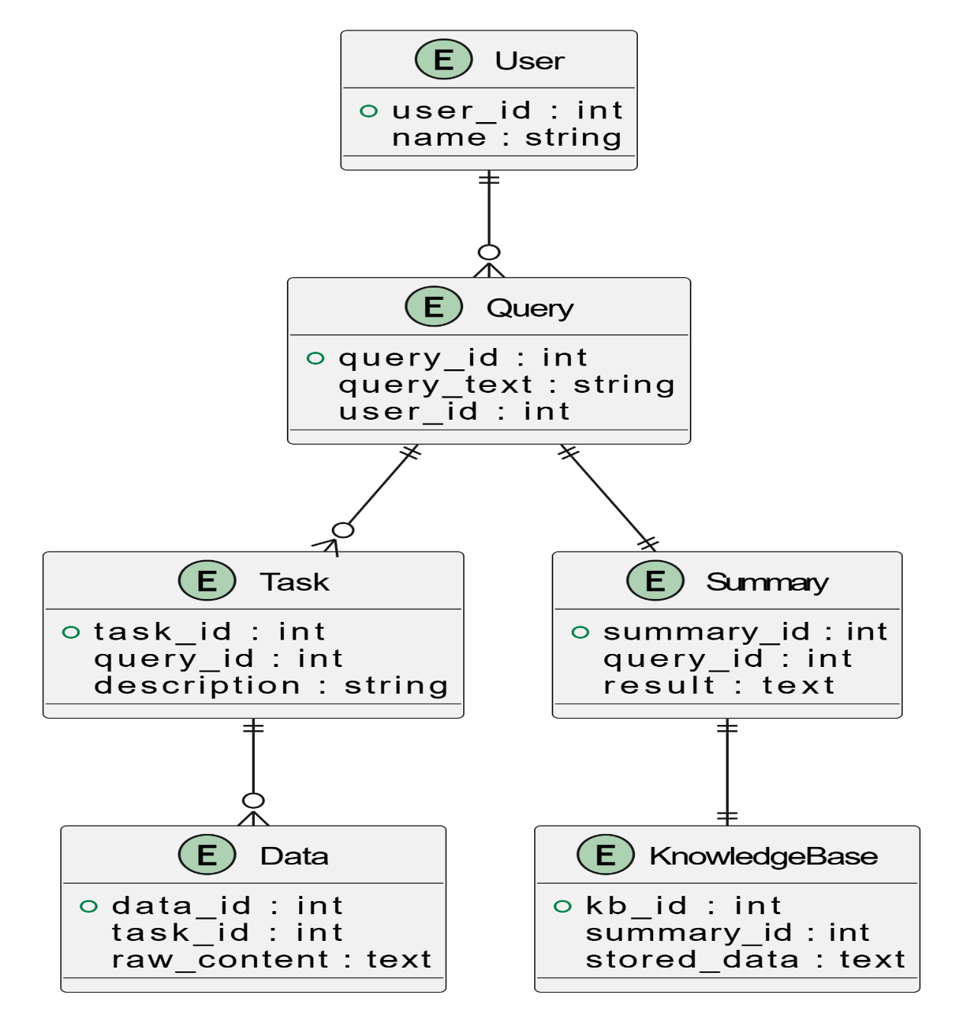

Data Flow Diagram(Level 0):
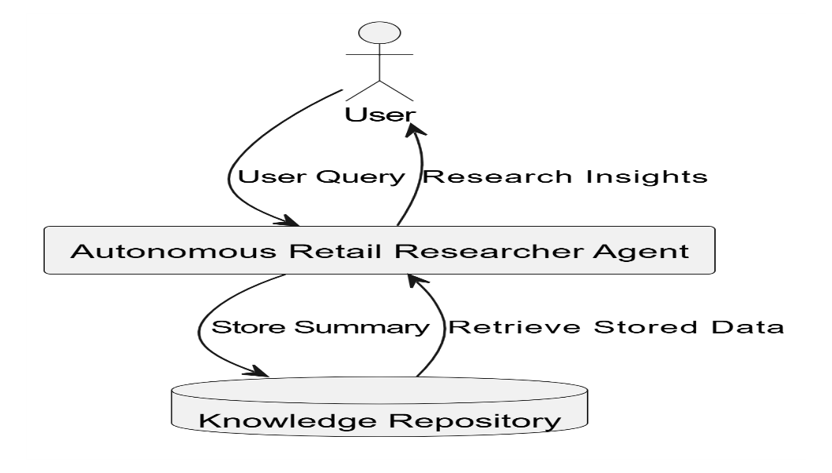
Data Flow Diagram(Level 1):
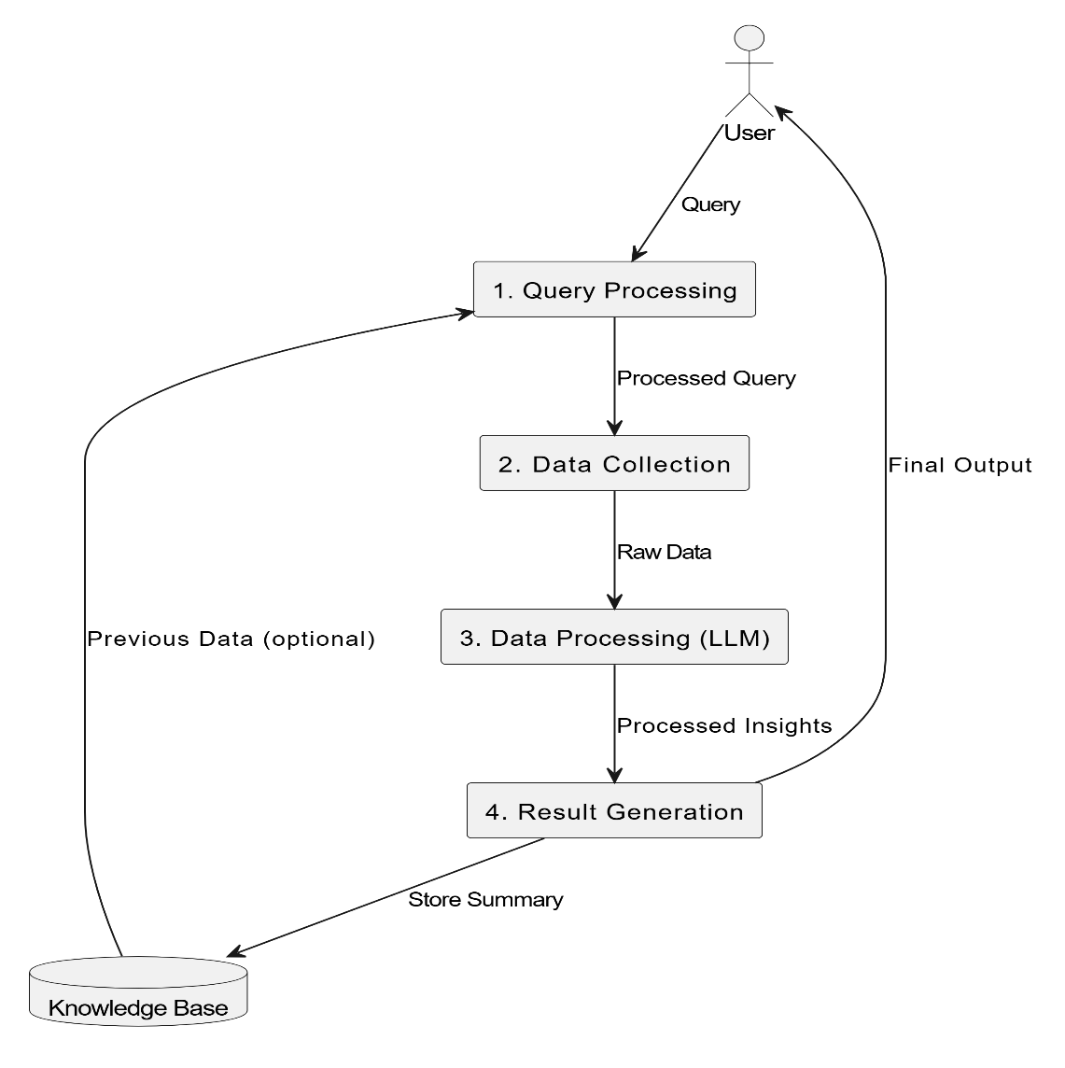

Data Flow Diagram(Level 2):
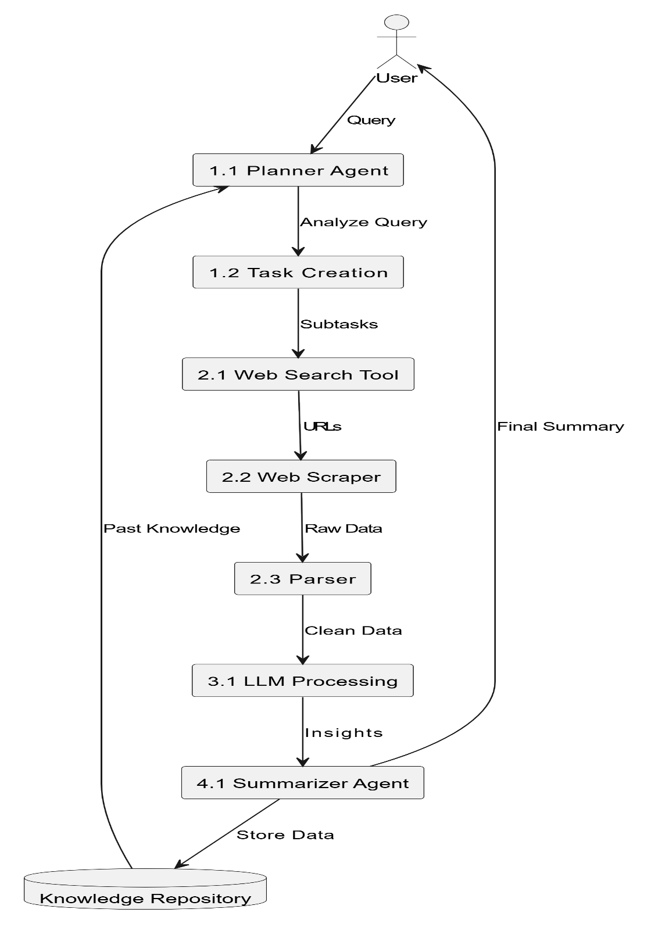

3. Data Design
3.1 Data Model
The system uses a hierarchical data model:
- A User Query is broken into multiple Tasks
- Each task generates Raw Data
- Raw Data is processed into Structured Data
- Structured Data is summarized into Insights
This model ensures efficient transformation of data from input to output.

3.2 Data Access Mechanism
The system uses backend services to manage data operations:
- Read Access: Retrieve stored summaries and insights
- Write Access: Store processed outputs and logs
- Access Control: Ensures only authorized access to data

3.3 Data Retention Policies
- Temporary data is stored only during execution
- Important insights are stored long-term
- Data is periodically cleaned to maintain efficiency
- Retention policies ensure optimal storage utilization

3.4 Data Migration
Currently, the system uses basic storage mechanisms such as text files or simple databases. In future, it can migrate to scalable cloud databases like MongoDB or PostgreSQL without major design changes.

4. Interfaces
The system interacts with both internal and external interfaces:
- User Interface: Allows user interaction
- External APIs:
  - LLM APIs for processing
  - Search APIs for data retrieval
- Internal Interfaces: Communication between agents and modules
These interfaces ensure seamless integration and communication.

5. State and Session Management
- Each query is processed as an independent session
- Temporary state is maintained during execution
- Context is stored in memory to ensure continuity
- Sessions are cleared after completion to optimize resources
This ensures efficient resource utilization and smooth execution.

6. Caching
Caching is implemented to improve performance:
- Frequently asked queries are stored
- Reduces repeated API calls
- Improves response time
- Enhances user experience
Advanced caching strategies can be implemented in future.

7. Non-Functional Requirements

7.1 Security Aspects
- Secure storage of API keys and credentials
- Input validation to prevent malicious queries
- Protection against unauthorized access
- Data encryption for sensitive information

7.2 Performance Aspects
- Fast response time for query processing
- Efficient handling of API calls
- Optimized data processing pipelines
- Minimal system latency

8. References
- LangChain Official Documentation
- CrewAI Official Documentation
- OpenAI / LLM API Documentation
- Research papers on Agentic AI and Autonomous Systems

